2014
INDEPENDENCE DAY SPONSORS & DONORS
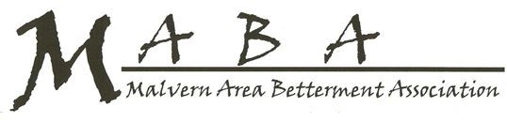
SPONSORS
Malvern Trust & Savings Bank
Kohll’s Pharmacy & Homecare
Classic Café

DONORS
AgriVision
American Legion, Harry Hammons Post
Anonymous
Dr. Tom & Sue Baer
Grace Blackman
Margeret, Ernest Bloomer, LuAnn Peverill
Bruce & Deb Breeding
Phil & Bev Dashner
John & Linda Downey
Fairview Hills Golf Club
Randy & Lori Greiner
Bev Hall
Scott & Dixie Hansen
Regee & Dee Hatfield
Joan Henderson
Jim & Monica Hughes
Larry & Brenda Koger
David & Sharon Lang
Mulholland Grocery
Don & Denell Moody
Darren & Megan Schnoor
Ken & Linda Seipold
Jeff & Joni Sell
Ruby Simms
Roger & Barb Slaughter
Ernie Spiker
Chris & Cheryl Stephens
Jay & Spencer Williams
Jeff & Lorraine Zanders

MEMORIALS
All Veterans
Mike Bloomer
Jim Kelly
Betty Sell
Henry & Edith Schnoor
Burdette Spiker

IN HONOR OF
Larry & Brenda Koger’s Grandchildren,
Drexel, Devin & Cordelia

Sincere “Thank You” to all our donor, sponsors and supporters.
We could not have had the celebration without you.
~MABA Membership.

